**实验0-1**  **eNSP软件安装前期准备**

**【实验目的】：**

eNSP软件的安装需要安装三个软件环境，包括：WinPcap、Wireshark、VirtualBox

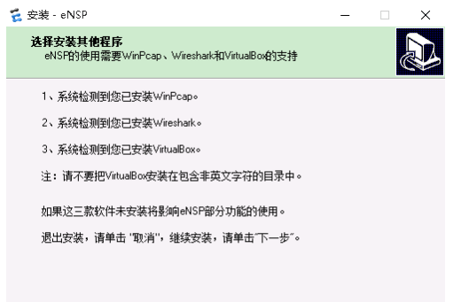

**【实验软件】：**

WinPcap、Wireshark、VirtualBox

**【实验步骤】：**

1. WinPcap安装：

|  |  |
| --- | --- |
| 1.1 | 双击安装程序 |
|  |  |
|  |  |
|  |  |
|  |  |
|  |  |
|  |  |

1. 安装wireshark

|  |  |
| --- | --- |
| 2.1 | 双击安装程序 |
|  |  |
|  |  |
|  |  |
|  |  |
|  |  |
|  |  |
|  |  |
|  |  |
|  |  |
|  |  |
|  |  |
|  |  |
|  |  |

1. 安装Virtualbox

|  |  |
| --- | --- |
| 1 | 双击安装程序 |
|  |  |
| 2. |  |
| 3. |  |
|  |  |
|  |  |
|  |  |
|  | 选择：“是” |
|  |  |
|  |  |
|  |  |
|  |  |
|  |  |